**Practical session 3**

*For the practical parts of this lab (implementing programs, running them) please save the Python programs that you create and take screenshots of the execution (evaluation) of your programs.*

**Reminder on “Input”:**

Input(“query”) can only return Strings (words).

If we want to ask the user for a number , we need to modify the process of using input(“query”), as a number is different to a word, or as we say an integer (whole number) is different to a String (word). So we need to convert the String we get from the input(“query”) function into an integer (number).

To do so we use a typecast (Details in the next lecture), that basically transforms the written number from the String into our integer number. It works like this:

mynumber = int(input(“Please enter a number”))

The “int” bit is transforming the String we get from our input function into the integer number format.

Caveat: We must actually enter a number, like “17” as input, as a numberword, like “seventeen” could not be transformed into a number.

**Tasks:**

1. 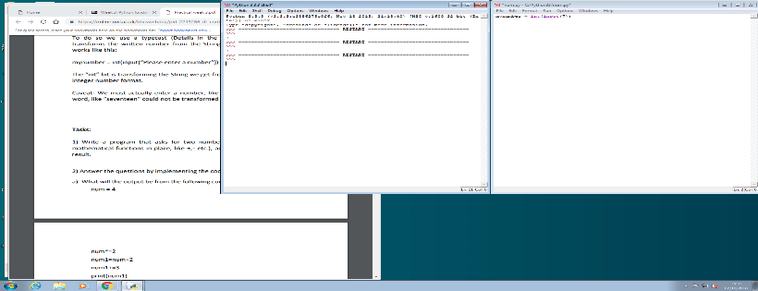Write a program that asks for two numbers (Python has all the basic mathematical functions in place, like +,- etc.), adds them up and displays the result.

1. Answer the questions by implementing the code and run it.
2. What will the output be from the following code?

num = 4

num*=2 num1=num+2 num1+=3 print(num1)

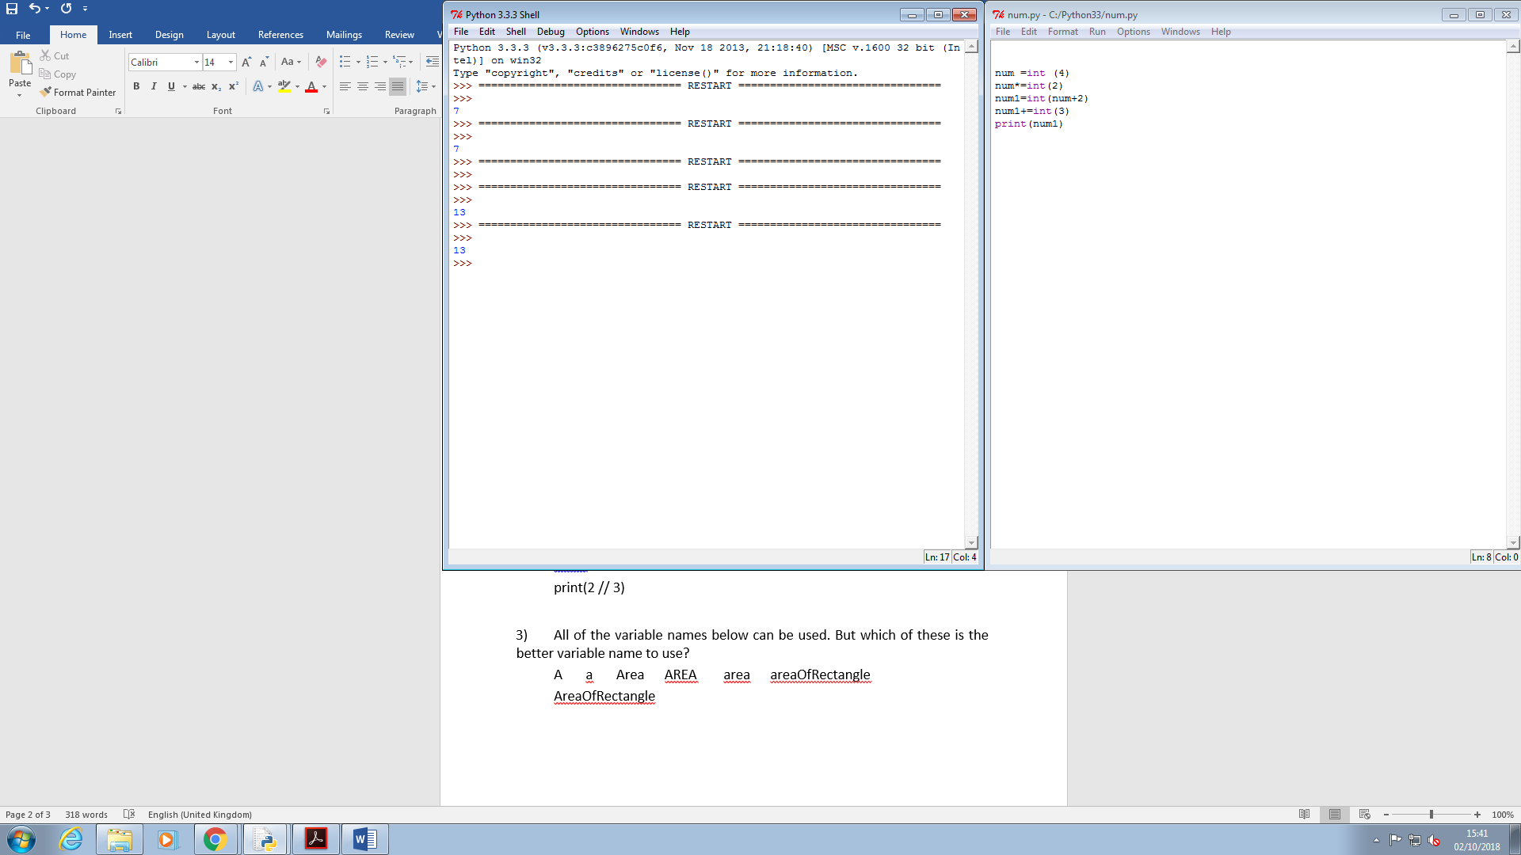

1. What do the following lines of code output? Why do they give a different answer?

print(2 / 3)

print(2 // 3) 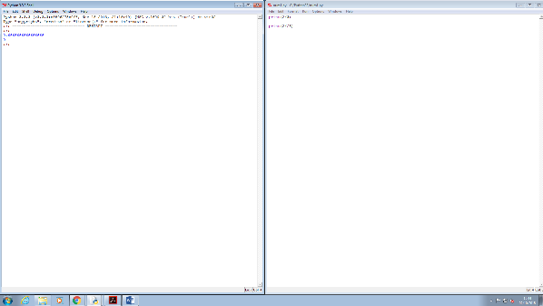

they both have different

1. All of the variable names below can be used. But which of these is the better variable name to use?

A a Area AREA area areaOfRectangle

AreaOfRectangle

1. Which of these variables names are not allowed in Python? (More than one might be wrong.) apple APPLE Apple2 1Apple account number account_number account.number accountNumber fred Fred return return_value 5Return GreatBigVariable greatBigVariable great_big_variable great.big.variable